**A CRM APPLICATIONS FOR SCHOOLS / COLLEGES**

**INTRODUCTION:**

**Overview:**

Customer relationship management (CRM) managers technology of a company for marketing. The responsibilities is to maximize the efficiency of the CRM data and software to improve customer care. These organization embraced CRM for educational institution to enhance experiences, track, and maintain information to develop a deeper and understanding of the processor and extended their outreach.

1. **PROBLEM DEFINITION & DESIGN THINKING:**

**EMPATHY MAP**

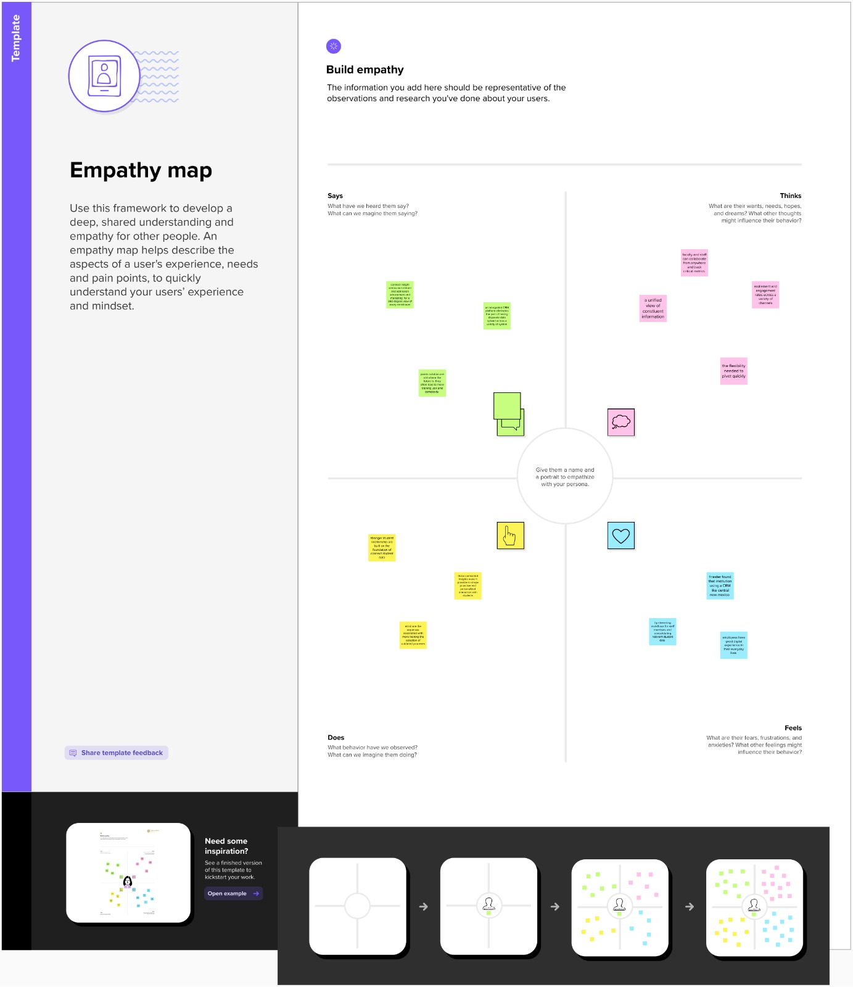

**IDEATION & BRAINSTORMING MAP:**

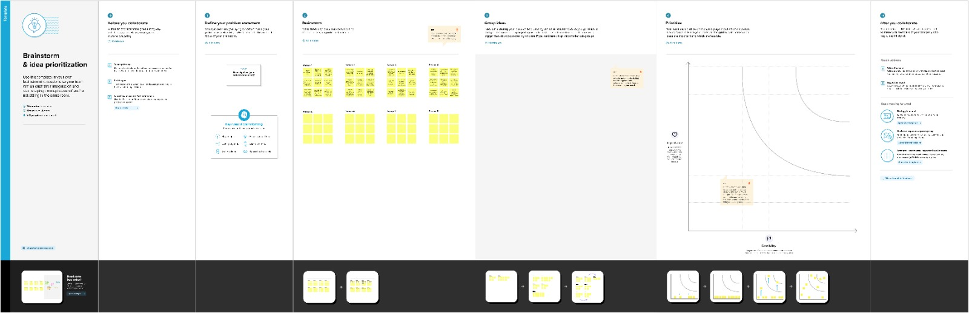

1. **RESULT:**

|  |  |  |  |  |  |  |  |  |  |  |  |  |  |  |  |
| --- | --- | --- | --- | --- | --- | --- | --- | --- | --- | --- | --- | --- | --- | --- | --- |
| SCHOOL | |  |  | | --- | --- | | Address | Text Area | | District | Text Area | | State | Text Area | | School websites | Text Area | | Phone number | phone | | Number Of Students | Roll-up summary | | Higest Mark | Roll-up summary | |
| STUDENT | |  |  | | --- | --- | | Phone Number | phone | | School | Master-Detail relationship | | Result | picklist | | class | Number | | Marks | Number | |
| PARENT | |  |  | | --- | --- | | Parent Address | Text Area | | Parent Number | phone | |

**DATA MODEL:**

**ACTIVITY AND SCREENSHOT:**

**CREATED DEVELOPER ACCOUNT:**

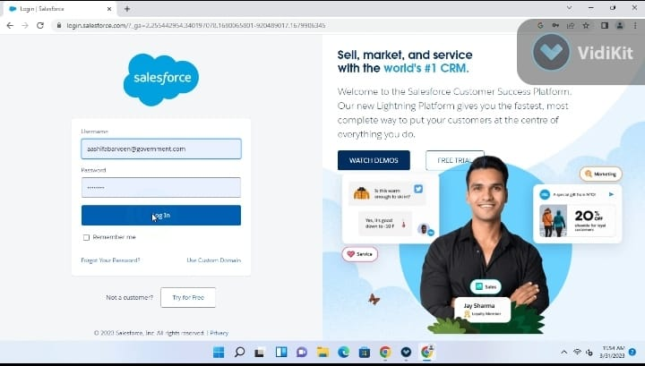

**OBJECT CREATION:**

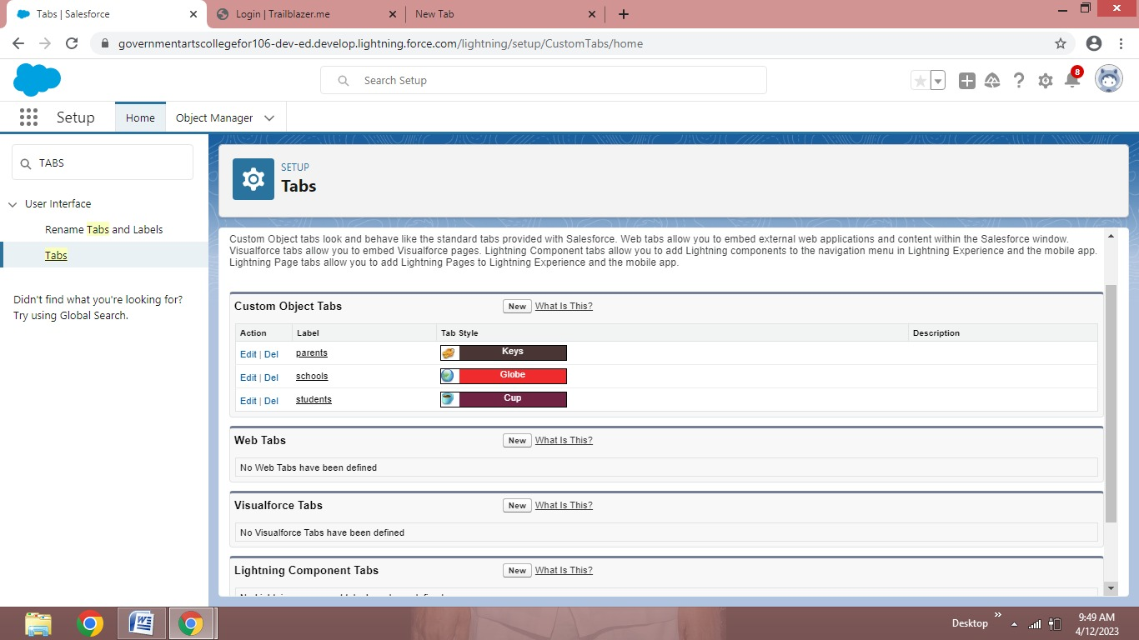

**SCHOOL MANAGEMENT APP CREATION:**

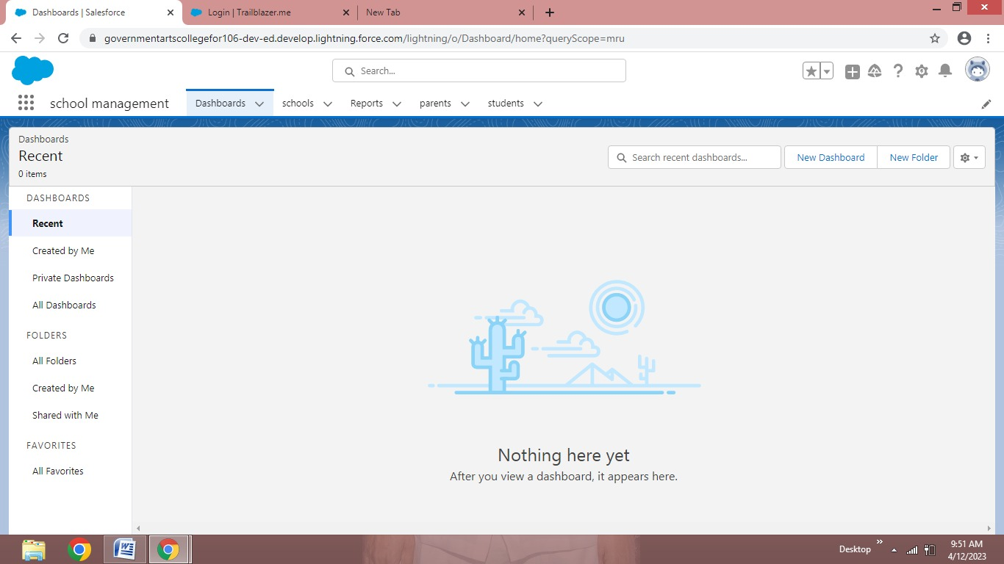

**USER CREATION:**

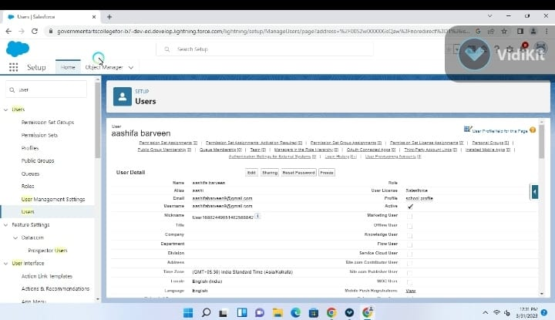

**PROFILE CREATION:**

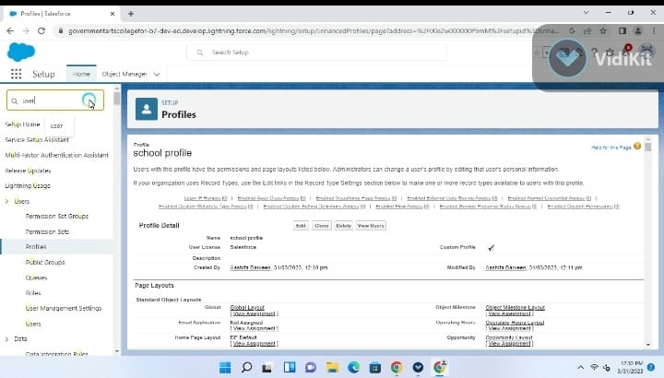

**REPORT CREATION:**

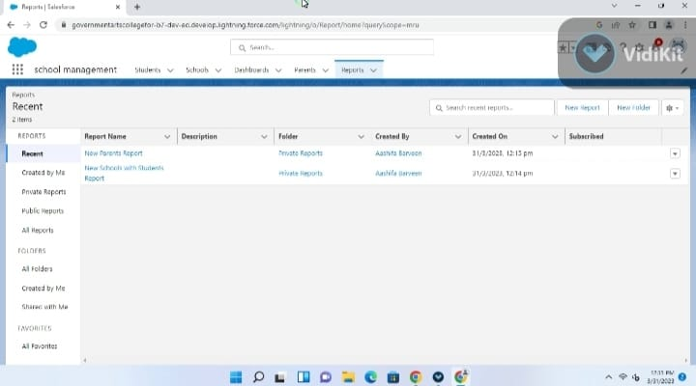

**TRAILHEAD PROFILE PUBLIC URL:**

**Team Leader - ABINAYA.J-https://trailblazer.me/id/abinj10**

**Team member 1-AASHIFABARVEEN.J-https://trailblazer.me/id/abarveen**

**Team member 2-ABIRAMI.M-** **https://trailblazer.me/id/arami413**

**Team member 3-ABIRAMI.R-** **https://trailblazer.me/id/abirr20**

1. **ADVANTAGES AND DISADVANTAGES:**

* An IT software tool that allows a business or individual full control over customer relationship
* Customers are explored
* Help in making sales and marketing strategies
* Create flexible solutions for customers support and analysis
* A force accelerator for diverse industries such as small businesses, mid-size businesses, and large multinational organizations

1. **APPLICATIONS:**

A CRM System can help education oranganisation effectivefly manage and track leads resulting in improved enrollment number.Additionally by personalising communication and providing automated follow-up,educational oraganisation can build better relationship with students and leads and keep them engaged over time

1. **CONCLUSION:**

Today it is not enough create an original course,it must be customized, adapted to the needs of a particular individual. CRM allows you to close the entire cycle by “correct” work with the client.A company that has mastered CRM technology will be able to outstrip its competitors

1. **FUTURE SCOPE:**

The CRM approaches has a greate future and advantages of CRM for educational oranganisations are undeniable. Many companies are no longer able to reduce their rates to attract customer all that remains is to compete on the basis of quality indicators including improved customers service and improved service level.

**“THE ABLITY TO CONNECT STUDENTS AND TEACHERS FROM DIFFERENT PARTS OF THE WORLD”**